Volunteer - Partners
Ascension Eagle River Hospital
Newsletter March 2019
Annual Meeting - Held at Eagle Waters Resort
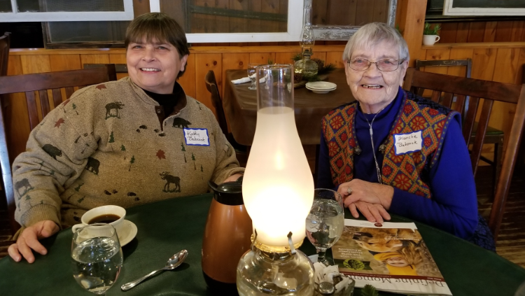
Members of the Volunteer Partners gathered for the January Annual Volunteer meeting at Eagle Waters to enjoy a beautiful dessert buffet while receiving an update on volunteer activities over the past year, as well as planned activities for the year ahead.

Proposed General Guidelines for Operation for the new volunteer structure – Volunteer Services, a department of Ascension Eagle River Hospital – were reviewed and approved. The group also received updates from the Membership, Community Health Education, Scholarship and Thrift Shop Committees.

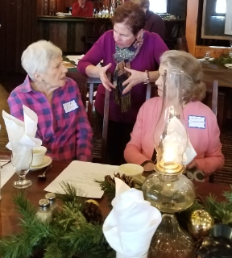
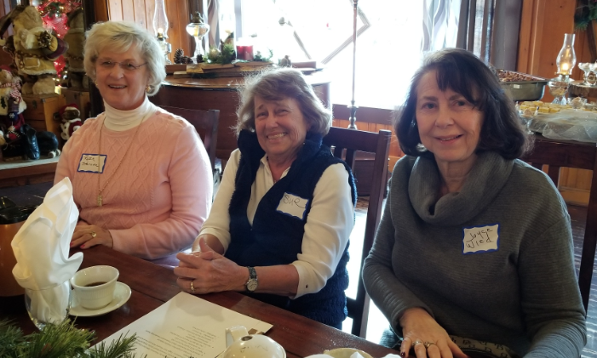
As part of the business of the annual meeting, the group voted to assist with funding 3D Mammography equipment so women in the Eagle River area can benefit from the latest breast screening technology and the renovation of space to create a tub
room (spa) so patients at Ascension Eagle River Hospital have the opportunity to experience a restful bath.
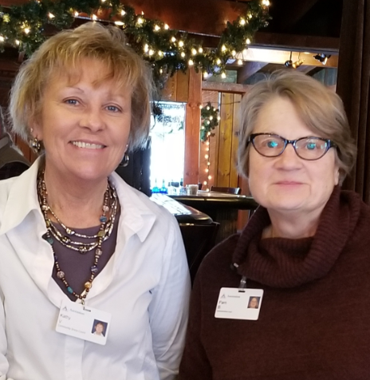 Kathy Viergutz (left) was recognized for the support she has provided to the volunteers over the past several years, as it was announced that Pam Berdal (right) will be serving as the Ascension Eagle River Volunteer Coordinator going forward. We “Thank You”, Kathy and “Welcome”, Pam.

Leading in partnership with & Support of
our volunteers

Thrift Shop Representatives Present Check to the Howard Young Foundation

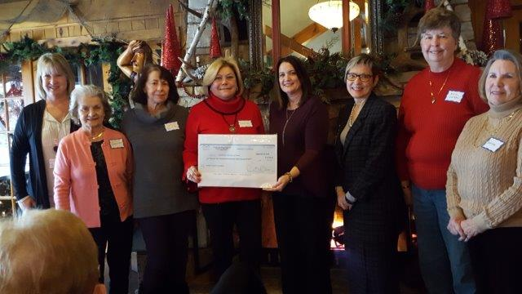
Pictured: Laurie Oungst, Chief Administrative Officer, Diane Schoessow, Joyce Wied & Diana Sell,
Thrift Shop Volunteers, Erin Biertzer, President Howard Young Foundation, Sandy Anderson,
Northern Region President, Karla Lokker & Andrea Mathews, Thrift Shop Volunteers

Erin Biertzer, President of the Howard Young Foundation was present at the January Annual Meeting to provide an update on the investment activity for the volunteer restricted funds. Representatives of the Thrift Shop, along with hospital leaders, presented her with a check in the amount of $72,000.
Volunteer - Partners Eagle River Hospital
Members of Partners of WHA

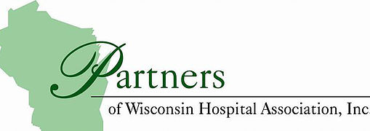

Partners of WHA is a non-profit volunteer organization which is made up of 7 districts. The Ascension Eagle River Hospital volunteers are part of the North Central District. Our district is comprised of 10 hospitals and we have 1,378 members.

We have two meetings per year. One is in the spring and one in the fall. Spring District Meeting is on April 4, 2019. Convention is October 1 – 3 in Appleton. These meetings give us the opportunity to network with similar volunteer groups to problem solve and share ideas.

We can also learn about what is going on in the other areas of Wisconsin by going on the website: partnersofwha.org and wha.org.

Community Health Education - Contributed by Diana Sell

The past two years we have addressed the Opioid crisis. While much more needs to be done, this year we will start to address a new and equally difficult health topic – mental health. It is officially entitled by the WHA, “Not all Wounds are Visible – A Journey for Mental Health”. How many times have we turned on our TV’s to see examples of a failure to address mental health? We see crimes, homelessness, substance abuse and suicide related to delusions, erratic behavior, fears, anxiety, emotional distress, and internal pain.
Mental Health is defined by the World Health Organization as a state of well-being in which every individual realizes his or her own potential, can cope with the stresses of life, can work productively, and is able to contribute to his or her community. There are many factors which contribute to mental health problems including biological factors, a family history of mental disease, seasonal factors, and life experiences. A mental health disorder may affect every aspect of your life and keep you from living it to the fullest.
Mental disorders are diagnosable illnesses which alter mood, behavior, and thinking processes and result in distress or the inability to function in daily life. One in four Americans experience a diagnosable mental disorder in any given year. Many are afraid to discuss their mental health issues and suffer in silence. Mental disorders are one of the leading causes of disability. As volunteers we can learn, understand and advocate for actions which provide both physical and mental health.
WHA Advocacy Day 2019
Wednesday, April 17, 2019
Monona Terrace Convention Center, Madison
There is no registration fee to attend Advocacy Day, but pre-registration is required. Contact Pam Berdal if you have an interest in attending.
Program Description
The Wisconsin Hospital Association’s Advocacy Day event draws over 1,100 hospital advocates from across the state each year to Madison. The event is designed to educate and motivate health care employees, trustees and volunteers on important health care-related issues and to encourage grassroots advocacy opportunities. Featured speakers give timely insight to state and federal health care issues and participating in legislative visits allows attendees to speak up on behalf of their hospitals.
Public Policy Education – contributed by Diana Sell
The best way for volunteers to have an impact on the legislation which affects our hospitals, patients and communities is to attend Advocacy Day in Madison on April 17, 2019 and/or become a member of HEAT (Hospital Education & Advocacy Team).
At Advocacy Day we have an opportunity to talk to our local state senator (Tom Tiffany) and assembly representative (Rob Swearingen) about issues regarding healthcare at our hospital and in our community.
We can express those same concerns to both them and our US senators and congressmen by becoming a member of HEAT. To become a member of HEAT you can sign up online at partnersofwha.org. HEAT alerts will be sent to your inbox with an explanation of the issue. There is even a prepared response (if you wish) that can be sent to the legislators describing your position on the issues.
To find out current issues you can go to the partnersofwha.org or wha.org websites.
A newsletter called “The Valued Voice” can be sent to your inbox which explains issues and the position your legislators are taking.
Being informed helps to understand changes and make informed choices.

Keynote Speaker
Governor Tommy G. Thompson
Did you know that the Agency for Healthcare Quality (AHRQ) rated Wisconsin 4th in the nation and 1st in the Midwest for quality? However, operating margins are decreasing. Workforce, health insurance coverage and government healthcare programs pose the three greatest challenges to sustaining Wisconsin’s superior quality care. Be informed and advocate for your hospital and community.

[Sidebar Title]
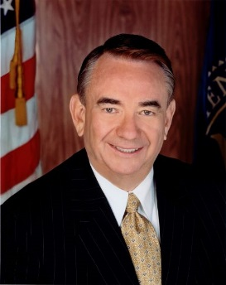
Events & Happenings
Thursday, April 4
WHA Partners NC District Meeting - Wisconsin Rapids

Wednesday, April 17
Advocacy Day – Madison

Thursday, June 13
Recognition Luncheon – Eagle River Inn

Tuesday, September 17
North Central Fall District Meeting – Minocqua

Thursday, September 19
Day of Renewal – Moon Beach – St. Germain

Tuesday – Thursday, October 1 – 3
Partners of WHA State Convention – Appleton

Your Time & Talent is Needed

Volunteer Advisory Board – A Volunteer Advisory Board is being established to ensure ongoing collaboration and partnership. The role of the Advisory Board will be to provide advice and guidance to the management of Eagle River Hospital (Coordinator Volunteer Services, Director of Nursing and Chief Administrative Officer) for the ongoing activities and support of the volunteer members. The Advisory Board will meet 4 times a year to give input, to react to ideas from management and to make suggestions that will advance the work of and collaboration with Ascension Eagle River Hospital.
Hospital Elder Life Program (HELP) – The Hospital Elder Life Program is a meaningful service provided to improve the hospital experience of older patients. Volunteer role includes:
- Daily visits designed to keep patients alert and aware by providing orienting communication and daily schedule as well as answering questions.
- Provide company and assistance with meals, encouraging oral intake to enhance nutrition and hydration.
- Initiate activities to keep minds active and relieve stress.

Out Patient Surgery –Assist patient care team in delivering patient meals, entering patient information into a ledger and assist in turn-over of patient rooms.

Interest? Contact Pam Berdal, Volunteer Services Coordinator 715-479-0327

April Birthdays
Jean Petras | 4/1
Kenneth Holdman | 4/2
Barbara Beschta | 4/4
Woody Eno | 4/5
Margo Granat | 4/9
Kathy Viergutz | 4/11
Diana Sell | 4/12
Dan Vladic | 4/12
Teri Kressin | 4/13
Blanche Babcock | 4/14
Marge Hanselman | 4/19
Senta Kant | 4/23
Linda Majewski | 4/30
May Birthdays  Jan Christofferson | 5/2
Diane Schoessow | 5/4
Barbara Flaherty | 5/7
Judy Jousma | 5/7
Donna Wilcox | 5/13
Rosemary DeBartelo | 5/14
Bernice Gilbert | 5/14
Ginger Gullan | 5/21
Jo Newman | 5/22
Judy Block | 5/26
June Birthdays  Joyce Wied | 6/2
Mary Lincoln | 6/3
Sherrie Mondus | 6/14
Beverly Ginnow | 6/17
Rosella Ong | 6/18
Louise Springer | 6/18
Celebrating YOUR Day…

…wishing YOU joy!!

“Volunteers don’t necessarily have the time; they just have the heart.”
-Elizabeth Andrew

