**AGENDA**

**Welcome**

*Power of Connection Background*

*Recruitment – Things to Ponder*

**Rethinking Volunteer Recruitment**

***Holly Daniels***

*MN Alliance for Volunteer Advancement (MAVA)*

**Sharing & Discussion**

*Choose the breakout room that best fits your needs*.

(5 breakout sessions based on your program status)

**Closing**

*Upcoming Events*

*Wrap-Up*

**Sponsored by “Power of Connection Regional Partnership”:**

Iowa Hospital Auxilians and Volunteers | Minnesota Association of Healthcare Volunteers

North Dakota Hospital Association | Partners of Wisconsin Hospital Association

**Holly Daniels**

**Greater MN Program Manager**

*MN Alliance for Volunteers Advancement (MAVA)*

In the past few years, people's priorities have shifted dramatically. Have our volunteer recruitment strategies shifted as well?

This presentation will focus on potential barriers that keep new volunteers from coming, and action steps for overcoming them. We will look at our recruitment messages and methods, and ask: "Can we better attract and invite people to consider involvement with us?"

***FREE Webinar***

**Rethinking Volunteer Recruitment**

*August 17, 2022 | 1:00 PM-2:30 PM CST | Virtual*

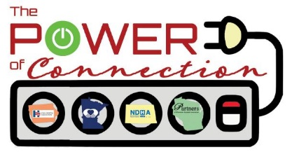

**Registration Required**

**For more information or assistance with registration contact:** Pam Gridley ([gridleyp@ihaonline.org](mailto:gridleyp@ihaonline.org)).

*Vice President, Corporate Relations*

*Iowa Hospital Association | 515-283-9306*