DRUG HABIT
****DEPENDANCE
ADDICTION/ABUSE 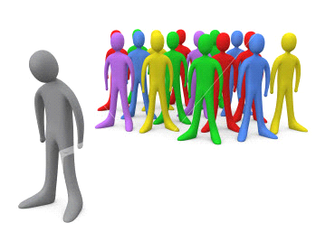
****SUBSTANCE USE DISORDER

Words Matter:

What we say and how we say it makes a difference to people with a substance use disorder.

NON-STIGMATIZING LANGUAGE STIGMATIZING LANGUAGE
• Person with a substance use disorder • Substance abuser or drug abuser
• Addict
• User
• Junkie
• Substance use disorder or addiction • Drug habit
• Use, misuse • Abuse
• Risky, unhealthy, or heavy use • Problem
• Person in recovery • Clean
• Abstinent
• Not drinking or taking drugs
• Treatment or medication for addiction • Substitution or replacement therapy
• Medication for Addiction Treatment • Medication-Assisted Treatment
Positive, negative (toxicology screen results) • Clean, dirty
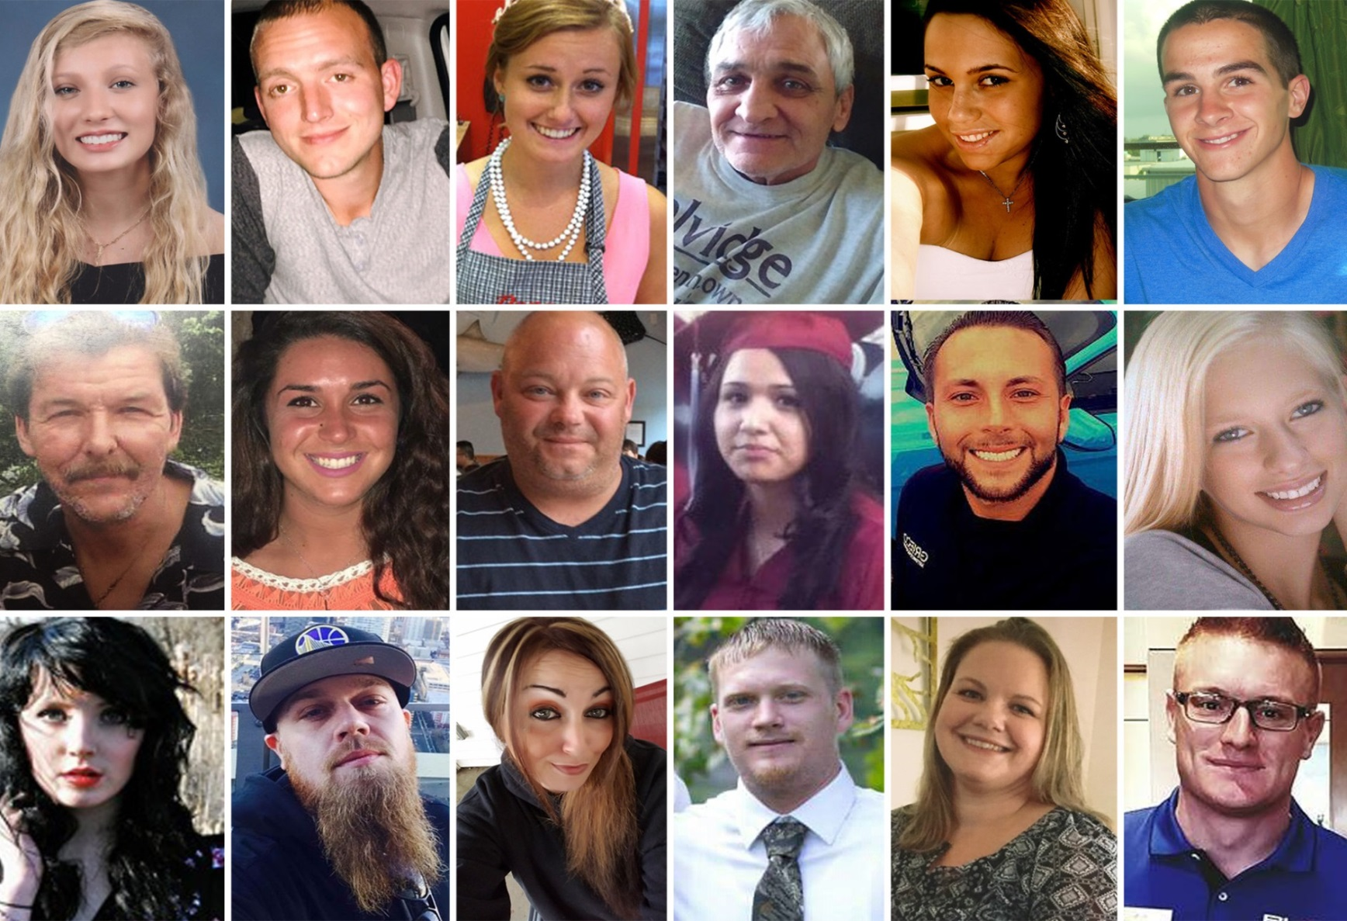
RISK FACTORS
Aggressive behavior in childhood
Lack of parental supervision
Poor social skills
Drug experimentation
Availability of drugs
Community poverty
PROTECTIVE FACTORS
Good self-control
Parental monitoring and support
Positive relationships
Academic competency
School anti-drug policies
Neighborhood pride
No single factor determines whether a person will become dependent on opioid drugs

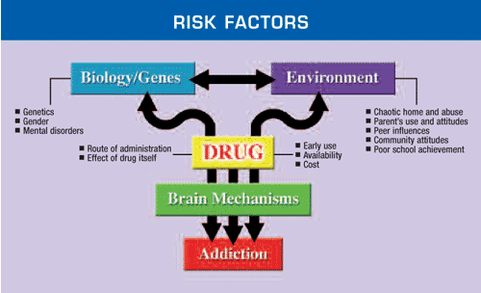
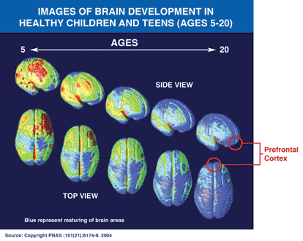
The brain areas still maturing during adolescence is the prefrontal cortex—that area enables us to assess situations, make sound decisions, and keep our emotions and desires under control.

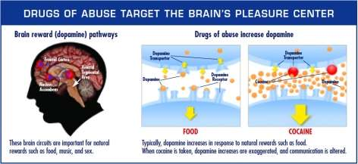
Can substance dependence be treated successfully?
Yes. Substance use is a treatable disease.
Can dependence be cured?
Not always—but like other chronic diseases, substance use can be managed successfully.

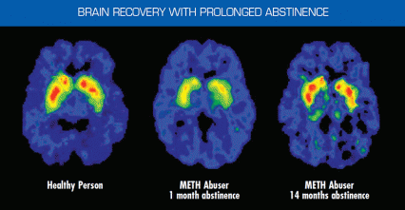

Source: The Journal of Neuroscience, 21(23):9414-9418. 2001
These images showing the density of dopamine
How can MEDICATIONS help treat substance use disorder?
- Treating Withdrawal

- Staying in Treatment.
Used to help the brain adapt gradually to the absence of the abused drug

- Preventing Relapse
Stress, cues linked to a drug experience (people, places, things, and moods), and exposure to drugs are common triggers for relapse. Medications are being developed to interfere with these triggers to help patients sustain recovery.

How do BEHAVIORAL THERAPIES treat Substance dependence?
- help engage people in substance use disorder treatment, modify attitudes and behaviors related to drug use and increase their life skills to handle stressful circumstances and environmental cues that may trigger intense craving for drugs and prompt another cycle of compulsive use. Behavioral therapies can also enhance the effectiveness of medications and help people remain in treatment longer.

SENIOR POPULATION

- In 2016, more than 4,000 Wisconsin residents aged 55 or older were hospitalized for opioid dependence or prescription opioid poisoning

- almost 1,000 emergency ambulance runs on Wisconsin residents aged 55 or older for suspected, unintentional opioid overdoses

- risk for family members and caregivers is high, since more than 70% of people get painkillers from friends and family.

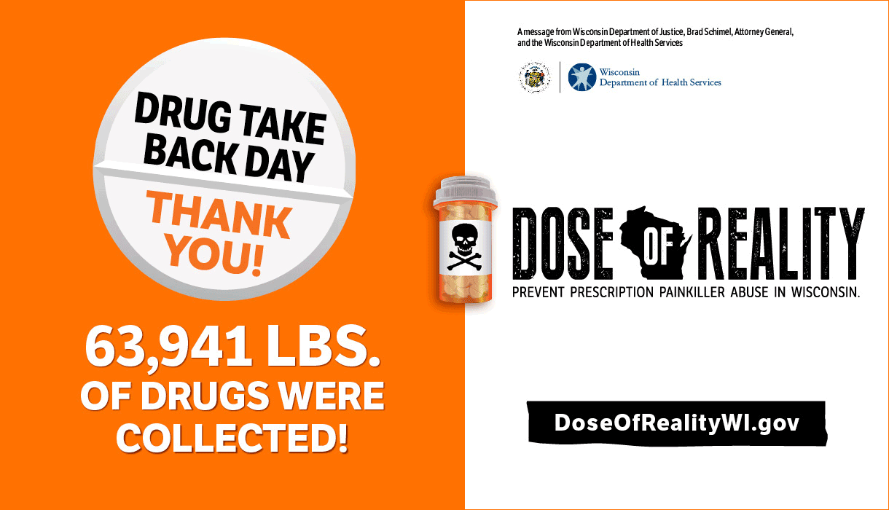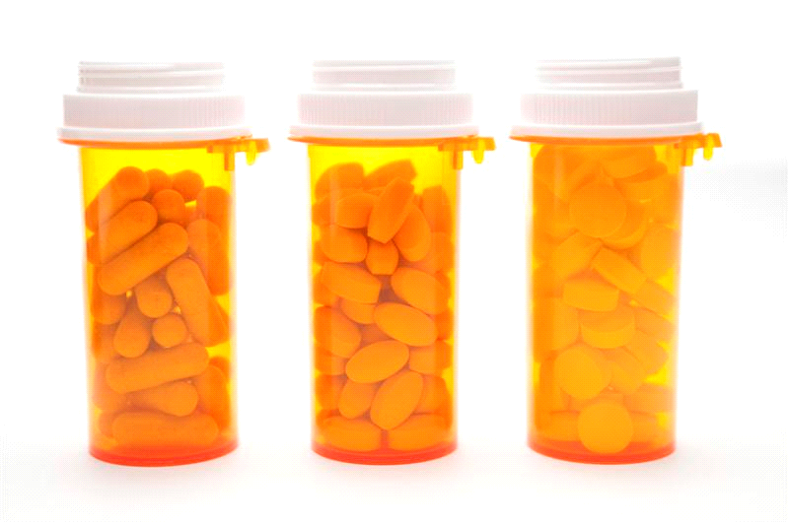
Safe disposal
Safe storage
Don’t mix
Don’t share

